The reality of legal weed in California: Huge illegal grows, violence, worker exploitation and deaths
By Paige St. JohnStaff Writer
Sept. 8, 2022 5 AM PT
At sunset from atop Haystack Butte, the desert floor below shimmers with a thousand lights.
Illegal cannabis farms.
At this hour and distance, serene hues cloak the rugged enclave of Mount Shasta Vista, a tense collective of seasonal camps guarded by guns and dogs where the daily runs of water trucks are interrupted by police raids, armed robberies and, sometimes, death. So many hoop houses pack this valley near the Oregon border that last year it had the capacity to supply half of California’s entire legal cannabis market.
Proposition 64, California’s 2016 landmark cannabis initiative, sold voters on the promise a legal market would cripple the drug’s outlaw trade, with its associated violence and environmental wreckage.
Instead, a Los Angeles Times investigation finds, the law triggered a surge in illegal cannabis on a scale California has never before witnessed.
Rogue cultivation centers like Mount Shasta Vista now engulf rural communities scattered across the state, as far afield as the Mojave Desert, the steep mountains on the North Coast, and the high desert and timberlands of the Sierra Nevada.
Residents in these places describe living in fear next to heavily armed camps. Criminal enterprises operate with near impunity, leasing private land and rapidly building out complexes of as many as 100 greenhouses. Police are overwhelmed, able to raid only a fraction of the farms, and even those are often back in business in days.
The raids rip out plants and snare low-wage laborers while those responsible, some operating with money from overseas, remain untouched by the law, hidden behind straw buyers and fake names on leases.
Labor exploitation is common, and conditions are sometimes lethal. The Times documented more than a dozen deaths of growers and workers poisoned by carbon monoxide.
The scale of the crisis is immense. A Times analysis of satellite imagery covering thousands of square miles of the state showed dramatic expansion in cannabis cultivation where land is cheap and law enforcement spread thin, regardless of whether those communities permitted commercial cultivation.
The boom accompanied a switch in cultivation technique, from annual harvests of outdoor plots to large, canopy-covered hoop houses that permit three to five harvests a year.
The explosive growth has had grave, far-reaching consequences, according to a Times review of state, county and court records as well as interviews with scores of local residents, legal and illegal cannabis growers, laborers, law enforcement, market analysts, community activists and public officials:
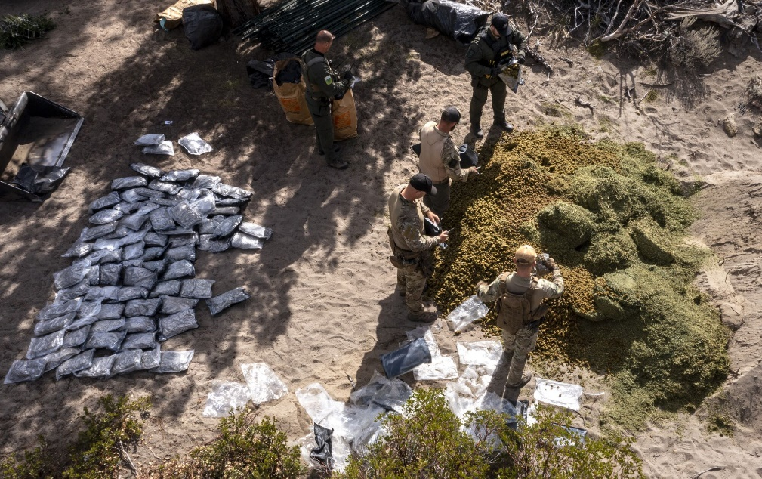
Law enforcement officers raid an illegal cannabis farm in Siskiyou County’s Mount Shasta Vista. They found hundreds of pounds of processed and unprocessed cannabis. (Brian van der Brug / Los Angeles Times)
- Outlaw grows have exacerbated cannabis-related violence, bringing shootouts, robberies, kidnappings and, occasionally, killings. Some surrounded residents say they are afraid to venture onto their own properties.
- Laborers often toil in squalid, dangerous conditions and frequently are cheated of wages. In four counties alone since legalization, carbon monoxide from generators and charcoal braziers has killed seven workers as they labored or tried to stay warm in sealed greenhouses on illegal farms, and eight more inside uninhabitable buildings, coroner records show.
- Intense cultivation is causing unmeasured environmental damage. Millions of gallons of water are being diverted at a time of severe drought, pulled out of aquifers even as the wells of local homeowners go dry. Unchecked chemical fertilizers have been deployed, along with banned, lethal pesticides.
- The immense scale of illegal cultivation fed a glut that crashed wholesale prices last year, jeopardizing even those in the licensed market. Small-scale legal farmers unable to sell their crop have been pushed toward financial ruin.
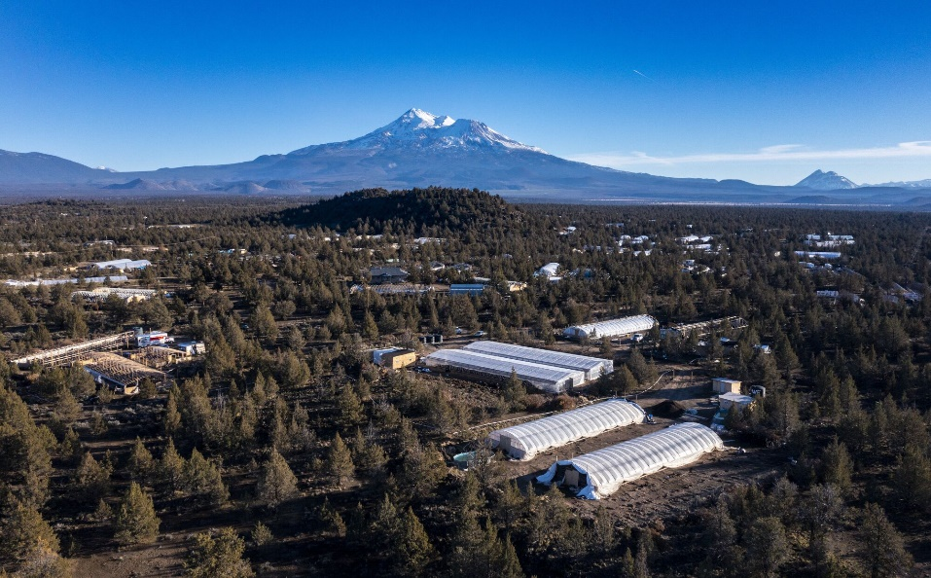
Illicit greenhouses fill the valley of Juniper Flat in the shadow of Mt. Shasta. (Brian van der Brug / Los Angeles Times)
The pitch for Proposition 64 focused on grand benefits: an end to drug possession laws that penalized the poor and people of color, and the creation of a commercial market that in 2021 generated $5.3 billion in taxed sales.
But California failed to address the reality that decriminalizing a vast and highly profitable illegal industry would open the door to a global pool of organized criminals and opportunists.
For those sidestepping taxes and regulation, the reduced criminal penalties included in Proposition 64 lowered the cost and risk of doing business.
Although no hard data exist on the size of the illegal market, it is indisputably many times larger than the licensed community. The Times’ analysis of satellite images shows that unlicensed operations in many of California’s biggest cultivation areas, such as parts of Trinity and Mendocino counties, outnumbered licensed farms by as much as 10 to 1.
Butte County, at the northern end of the state’s Central Valley, tried to ban commercial cultivation, but the area covered by cannabis greenhouses in Berry Creek soared 700% in five years. Ravaged by wildfire, it is not rebuilt homes but the shiny plastic of greenhouses that gleams between the charred black skeletons of the forest.
Neither a ban nor lack of water dissuaded outlaw growers from erecting hoop houses on the desert sands of Lucerne Valley, where the state mapped 13 cannabis plots before legalization and The Times last year found 935 greenhouses. A still-running campaign by the San Bernardino County sheriff in 12 months razed more than 8,200 greenhouses without running out of targets.
California has done little to address the crisis.
Enforcement efforts against the illicit market are spread across a variety of state agencies with insufficient resources and very different priorities. Seven years after water regulators set out to map and measure the impact of cannabis cultivation in California, the work remains unfinished.

It’s like taking on a gargantuan army with a pocket knife.
— Mendocino County Sheriff Matt Kendall
Under Gov. Gavin Newsom, a champion of legalization, California has subscribed to an industry-backed theory that market forces will eventually squeeze out illegal growers. When licensed growers this year complained they could not compete, Newsom agreed to tax breaks and his administration created incentives to expand the market by giving grants to communities that allow commercial cannabis.
At the same time, he increased the penalties against those that don’t. Communities that prohibit commercial cannabis are already barred from key state enforcement grants. A measure written into Newsom’s budget bill also blocks them from the closed-door meetings of a task force set up to advise the governor’s administration on cannabis policy, including what to do about the illegal market.
Illegal cannabis’ thorniest challenges fall on overwhelmed local law enforcement agencies and code enforcement departments, ill-equipped to contend with criminal networks behind the growth.
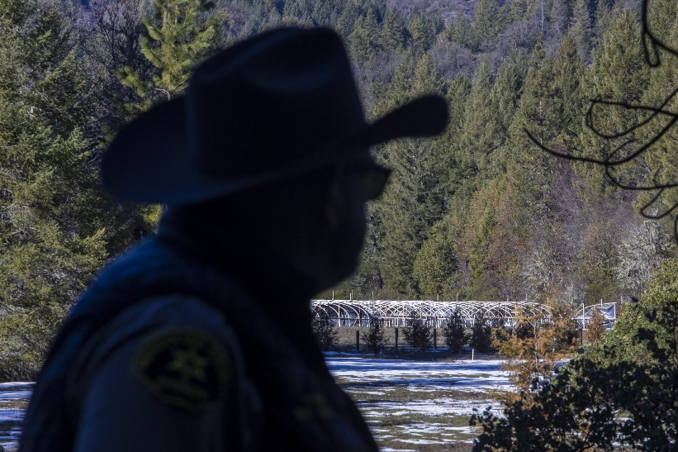
Mendocino County Sheriff Matt Kendall looks from a distance at an illegal cannabis grow near Covelo. (Brian van der Brug / Los Angeles Times)
The rugged forests and valleys of Mendocino County, deep in the heart of California’s famed Emerald Triangle, renowned for the quality and quantity of its weed production, have an estimated 5,000 illegal cannabis farms. The grows range from homestead farms to dangerous drug-trade operations, such as one where deputies this spring found an AK-47 modified for full-automatic fire.
The sheriff’s cannabis enforcement team consists of a single sergeant and a part-time deputy. They try to identify the worst offenders, borrow officers from neighboring counties for raids and ignore the rest.
“It’s like taking on a gargantuan army with a pocket knife,” said Sheriff Matt Kendall.
Noel Manners’ licensed farm had a problem — too much cannabis.
Regulators in 2020 sent satellite images that showed large hoop houses on his Mendocino County property that were not permitted under his state cultivation license.
But Manners knew the offending weed wasn’t his.
A large illegal grow had crept onto his 800-acre timber tract. Manners waited for winter, when he knew the operation would be dormant, and hiked up the hillside. He found trees felled for a half-acre clearing, three giant plastic-covered hoop houses, and — especially repugnant because the longtime grower was a leader in organic cannabis farming — chemical fertilizers spilled on the ground.
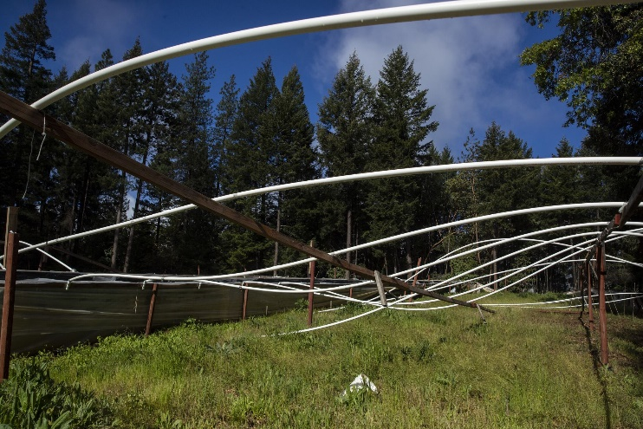
Despite repeated attempts to remove it, an illegal cannabis operation continued to trespass on Noel Manners’ licensed farm in Mendocino County. (Brian van der Brug / Los Angeles Times)
Manners shoved the outlaw operation back across his fence line with his mini-dozer. It returned the next spring — with unwelcome signs of activity.
Soap suds frothed in his mountain pond. Gunfire echoed at night. Walking his land one rainy day, Manners smelled something foul.
“I saw these little white, almost like, flowers on the ground,” he said.
He was standing in a field of toilet paper.
Manners, 63, was a pioneer in cannabis, a former bicycle shop owner with a laid-back smile and the habit of hanging his eyeglasses on the collars of his Grateful Dead T-shirts. He left the Sacramento Valley three decades ago to move his family to this remote mountain overlooking Round Valley.
He joined the generations of growers who dodged the law while building an economic and social fabric that filled the void left by the collapse of the timbering industry.
When California led the nation by legalizing medical marijuana in 1996, he and other farmers became part of a gray market — one that fostered sham medical recommendations and farms of 99 plants, one less than the federal threshold for a mandatory five-year prison term. Absent state regulation, permitting took the form of zip ties sold by the sheriff to identify legal plants and protect them from raids.
Manners successfully navigated every shift in California’s unstable cannabis landscape. He developed strains that would help form the foundation for today’s industrial growers. High Times, the counterculture magazine dedicated to weed, heralded his off-the-grid operation, Camp Cool, as one of the nation’s premier sun-grown cannabis farms.
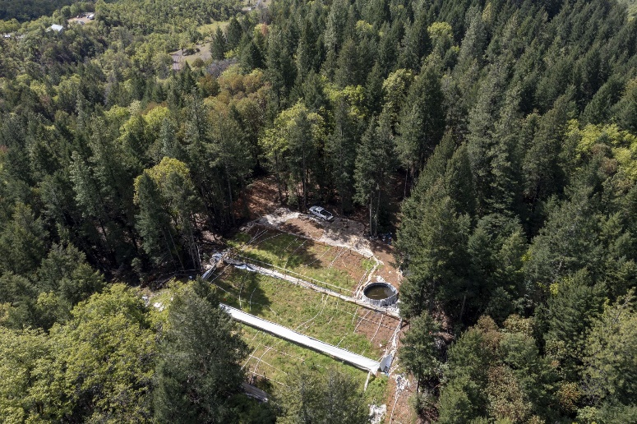
Trespassers cleared trees to set up an illegal cannabis grow on Noel Manners’ licensed farm in Mendocino County. (Brian van der Brug / Los Angeles Times)
The interlopers on his mountain made Manners uncomfortable. He would not go near the grow if it was occupied. But he could not avoid them.
Manners met growers cutting through the woods, one carrying an assault rifle. Another had a bandanna over half his face.
“I pointed at them and said, ‘This is my land. I’m the one who put up the “No Trespassing” signs and whatnot last year.’ And then I asked them, ‘So how long, when are you guys going to be finished and be off of my land?’
“And they said, ‘Oh, 10 weeks...’
“And I said, ‘Good enough.’ That was my cue to leave.”
In July 2021, Mendocino County sheriff’s deputies finally raided the operation.
Manners returned to the site this winter, and discovered the operation still standing. Three enormous hoop houses stood ready, each the length of two houses. Three giant Doughboy swimming pools were set up for mixing chemical-laden water for “fertigation.”
“They’re getting ready for another expansion,” Manners said as he documented the grow with his phone, his gray ponytail reflected in the glass of the abandoned truck. He pointed out an overturned truck camper top, and enclosures made from black plastic hung from the trees — makeshift toilets.
Manners died unexpectedly in early April, falling and cracking his head after the main artery from his heart suddenly tore. His brain swelled and he did not regain consciousness after emergency surgery. Afterward, his son noticed something uncharacteristic on his father’s nightstand: a .44 magnum pistol.
A coiled belt of ammunition sat on the shelf below.
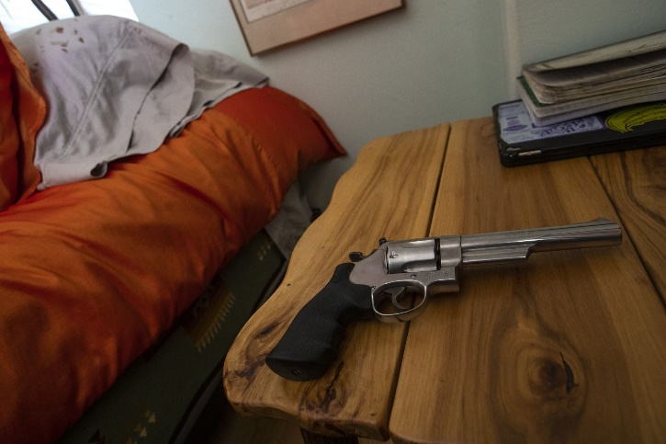
The .44 magnum found on Noel Manners’ nightstand. (Brian van der Brug / Los Angeles Times)
In the run-up to California’s 2016 watershed cannabis vote, Mouying Lee positioned himself at the forefront of a wave.
He moved from Fresno to Siskiyou County’s high desert to snap up scores of cheap lots in a failed vacation resort called Mount Shasta Vista, little more than a spiderweb of cinder paths bulldozed between lava rock and juniper scrub.
Then Lee sold most of the dusty, empty plots to Hmong like himself. Hundreds moved from across the United States to the area populated mostly by white hay farmers and cattle ranchers.
The would-be entrepreneur described his vision of a cultural center for his people, Laotian refugees persecuted for siding with the U.S. during the Vietnam War.
But in the dry volcanic valley, punished by sun and desiccating wind, the newcomers built virtually no homes. They slept in sheds, or beneath tarps, and tended 99-plant gardens of cannabis, one leafy stalk short of the federal cutoff for prison. When the snow arrived, they and the harvest disappeared.
Similar cannabis-centric enclaves emerged across Northern California, often named after Laotian mountains or battlefields. They were controversial in the Hmong community, but even critics said the farms provided a steady flow of cash to a struggling population of immigrants.
California’s legalization of recreational cannabis in 2016 ushered in a multibillion-dollar industry estimated to be the largest legal weed market in the world. But many of the promises of legalization have proved elusive. In a series of occasional stories, we’ll explore the fallout of legal pot in California.
Read the stories
Lee said most of the cannabis in Mount Shasta Vista was grown for personal use and “the old way of medicine,” such as brewing cannabis tea and putting it in the shower for steam baths. He voiced dismay that Siskiyou County’s more established residents accused the Hmong arrivals of organized crime.
Law enforcement frequently intercepted shipments of hundred-pound parcels of cannabis sent from the Mount Shasta Vista farms. The sheriff’s posse mounted dawn raids and the county Board of Supervisors passed ordinances that not only banned commercial cannabis but the water deliveries that kept the grows green.
Lee said it was a cultural misunderstanding, if not overt racism.
Court filings show Lee was central to a highly organized cannabis operation. Investigators raiding his houses found water delivery schedules and receipts for dues for a 534-member association. The files tracked members’ medical marijuana cards and voting records as well as search warrants executed by the sheriff. An investigator alleged the organization even insured members against losses from raids. In texts admitted into the court record, Lee brokered cannabis sales by the hundreds of pounds to buyers flying in from afar.
With the opening of the recreational cannabis market, Lee expanded beyond his Hmong clientele. He bought large parcels outside Mount Shasta Vista, bulldozing one 620-acre tract so barren the scar is visible from space. Dubbed the “Cinder Pit” by police, it contained 82 plots, each with two greenhouses and a shed. Tenants arrested during drug raids told police they had leased their plots for $10,000 a season.
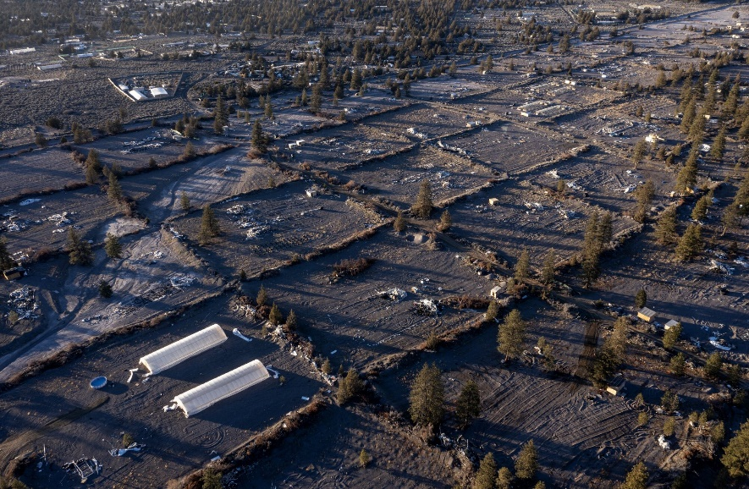
Mouying Lee flattened a 620-acre parcel in Siskiyou County that police dubbed the “Cinder Pit” and carved it into 82 plots for cannabis grows. (Brian van der Brug / Los Angeles Times)
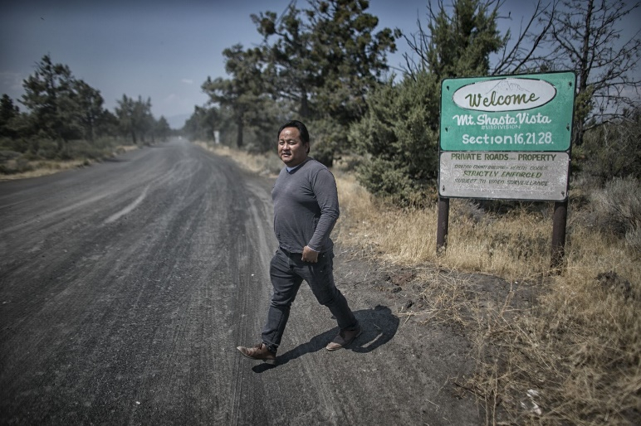
Mouying Lee began buying property in the Mount Shasta Vista area of Siskiyou County more than six years ago that he said would become a Hmong community. (Robert Gauthier / Los Angeles Times)
It was not the sheriff but a tax agent who stopped Lee’s expansion.
In 2020, with help from the California Franchise Tax Board, county authorities charged Lee with money laundering and tax fraud, accusing him of hiding some $1.5 million in unreported earnings. Lee pleaded not guilty. Prosecutors asked a judge to set his bail at $3 million, but Lee was released on his own recognizance.
Even with Lee sidelined, the expansion of cannabis farms in Mount Shasta Vista continued, attracting other groups who spilled out across the valley of Juniper Flat.
Single-family plots gave way to multi-season greenhouses. Some built industrial-scale complexes that made the small Hmong camps look timid.
“I never thought it was going to be like that,” Lee said this spring as he paced the upper balcony at the courthouse, waiting for his Beverly Hills lawyer to fly in for settlement talks with the county prosecutor.
At night the cannabis camps glow like a small city. The Times mapped more than 1,300 farms in Juniper Flat last year. Their greenhouses covered more than 10 million square feet, a 4,200% increase since 2018.
It is the densest known concentration of illegal cannabis cultivation in California.
Once the dominion of ranchers and retirees, the valley has taken on outlaw qualities. Lookouts are posted at entrances off the highway. Armed robberies are frequent. In 2018, deputies seized seven guns during raids on illegal farms. Last year, they found 66. This spring, police were summoned to one farm to fetch two intruders left tied to a fence post.
Last month, four men who appeared to be in their 30s surrounded a Times photographer parked along the public highway outside Mount Shasta Vista, where he had stopped to document water trucks in the distance filling up at a hay farmer’s well. One of the men took out a tire iron and began hitting the photographer’s car, denting the body and smashing the rear windshield and a sideview mirror.
Another told him: “The only reason you don’t have a bullet in your head right now is because you are talking to me.”
Two years ago, masked assailants attacked a Mount Shasta Vista grower and his companions, tied them up and killed the grower. Police suspect it was an execution. It remains unsolved.
Also that summer, three men from Southern California carrying AR-15-style assault rifles tried to rob growers. In the ensuing shootout, one of the men was killed and his wounded accomplices fled on foot through the rocky cannabis farms, calling 911 to beckon police to their rescue. That killing also remains unsolved.
So do the killings of two Hmong women from Milwaukee in 2019. They were shot on a cannabis farm near the Oregon state line, where another enclave has settled, rarely visited by police.
Since 2016, at least eight cannabis growers in Siskiyou County have died of carbon monoxide poisoning as they tried to keep warm with charcoal braziers and unventilated generators, according to coroner records obtained by The Times. The body of a ninth carbon monoxide victim was found last year dumped on the side of Interstate 5, wrapped in his sleeping bag. Police have no clue where he died, but they presume it was a cannabis operation. Six of the dead were Hmong.
Det. Sgt. Cory Persing commands the county drug enforcement unit, wrestling not just with cannabis but fentanyl, meth and everything else. The five-person unit is down to two, Persing and another sergeant, so they must call for volunteers from the jail to staff raids.
Because of the Proposition 64 prohibition barring counties that do not permit commercial growing from state enforcement grants, they rely on funding from the federal Drug Enforcement Agency.
The ballot measure also dramatically lowered the cost of business for illegal operators, reducing the criminal penalty for unlicensed cultivation from a felony punishable with time behind bars to a $500 misdemeanor no matter how large the crop. To bring a felony case that might shut down an operation, state prosecutors must find other charges. That requires investigators.
Persing has none.
He is caught in an endless cycle of writing search warrants and ripping out plants. Nine out of 10 grows go untouched. He has returned to raided farms three days later to find them back in operation.
A water delivery truck rumbles down a dusty cinder road in the Mount Shasta Vista community.
On a sunny day in October, Persing’s team hit four small growing camps. Alerted by the lookouts, the growers had fled by the time the convoy arrived. Only a penned dog was left, snarling and snapping, a pile of dry food on the ground kicked through the bars as though even its owners were afraid to get close.
Officers used a mini-dozer to raze cannabis beneath a hoop house built out of PVC pipe, while Persing peered inside one of the plywood sheds used for habitation. He laid the search warrant and a receipt for 157 pounds of seized cannabis on a mattress set on two-by-fours, beside an empty rifle case.
An outdated watering schedule hung on the unfinished wall. The shed held personal financial papers for at least four people, and an offer to buy 70 acres in eastern Oklahoma where there is a cannabis land rush. A garbage pail and a plastic bucket in a makeshift stall suggested a shower. A single-burner camp stove suggested cooking, but there was no food.
Persing stood on the ridge road, sunglasses perched atop his close-cropped head, and pointed out Mount Shasta Vista.
Then he used his arm to trace the expansion since 2019. In the valley below, the white forms of hoop houses stretched for miles.
“This is all of the new stuff,” Persing said, sweeping his arm east across the valley. “I mean, like, prior to this, there was one house up in here. It has just grown, swoosh, all the way around.”
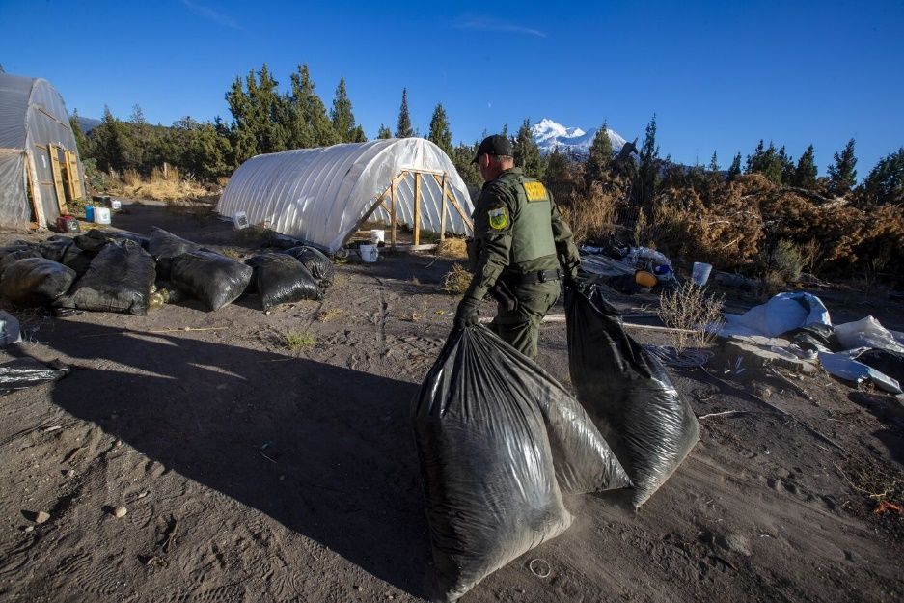
A Siskiyou County sheriff’s officer drags bags of cannabis for destruction during the raid of an illegal farm in Mount Shasta Vista. (Brian van der Brug/Los Angeles Times)
A cellphone and trimmed cannabis flowers were left behind by workers who fled an illegal Siskiyou County farm before the arrival of sheriff’s deputies. (Brian van der Brug/Los Angeles Times)
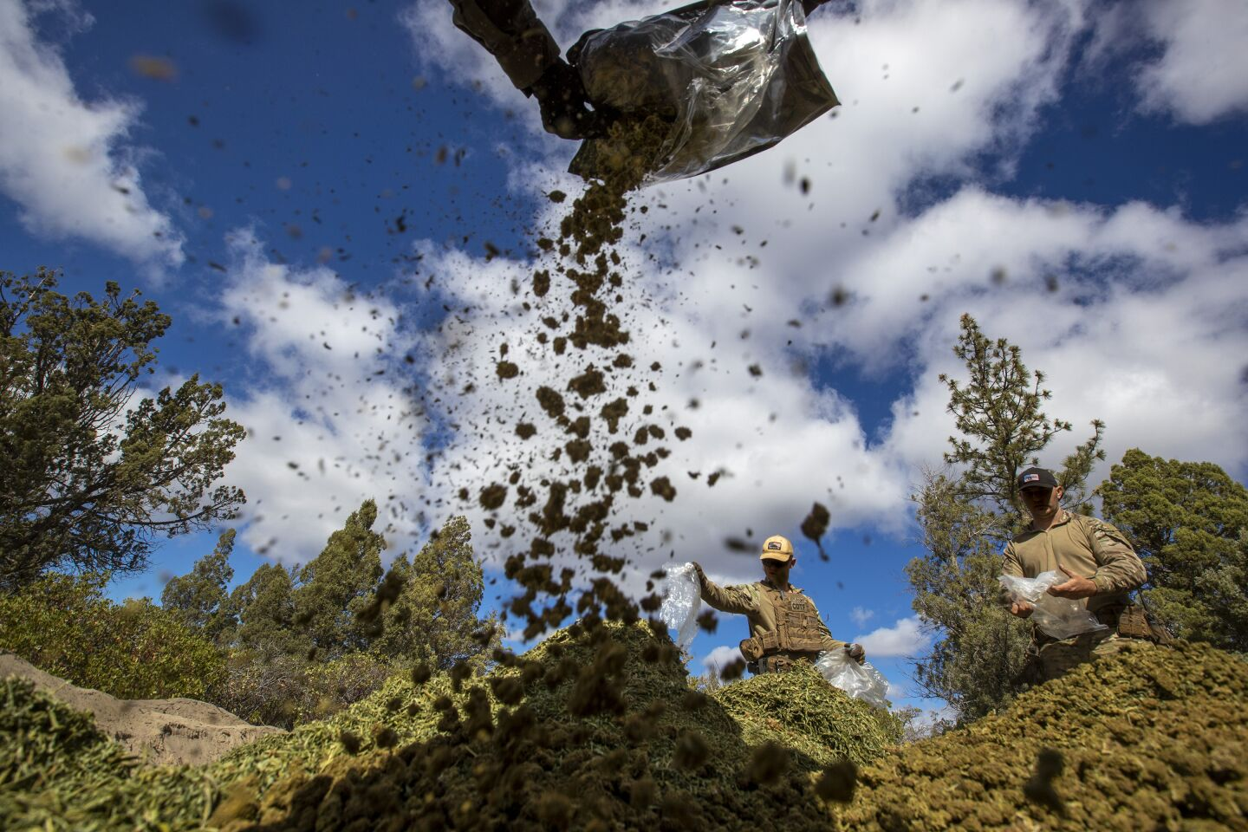
Officers dump hundreds of pounds of processed cannabis into a trench for burial during raids in Siskiyou County. (Brian van der Brug/Los Angeles Times)
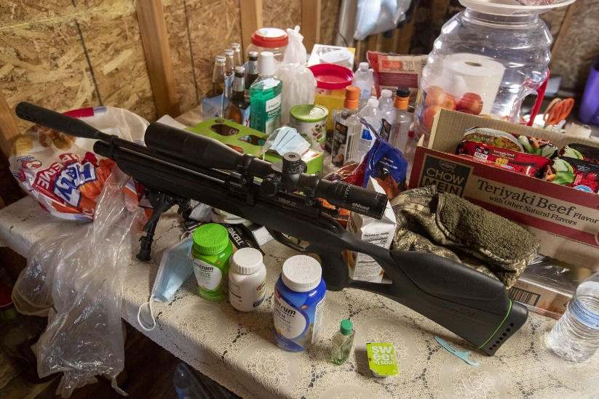
A .22-caliber scoped rifle sits amid personal items and food in the kitchen area of a shed at an illegal cannabis operation in Siskiyou County. (Brian van der Brug/Los Angeles Times)
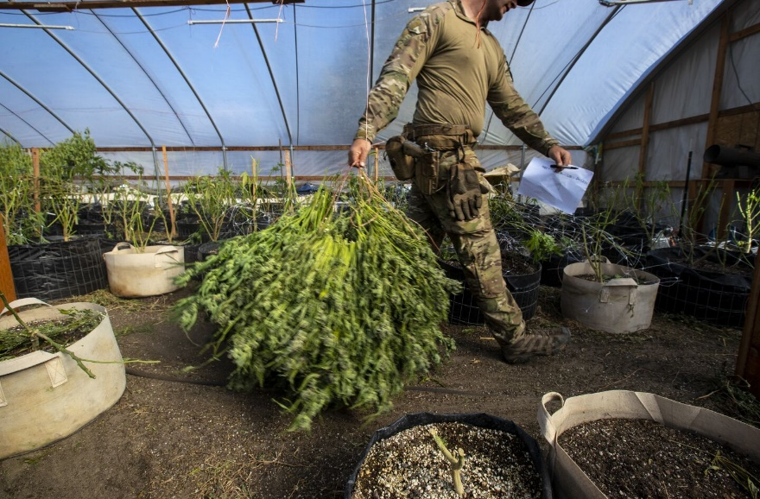
A member of a Siskiyou County sheriff’s task force drags cannabis plants out of a greenhouse for burial during a Mount Shasta Vista raid. (Brian van der Brug/Los Angeles Times)
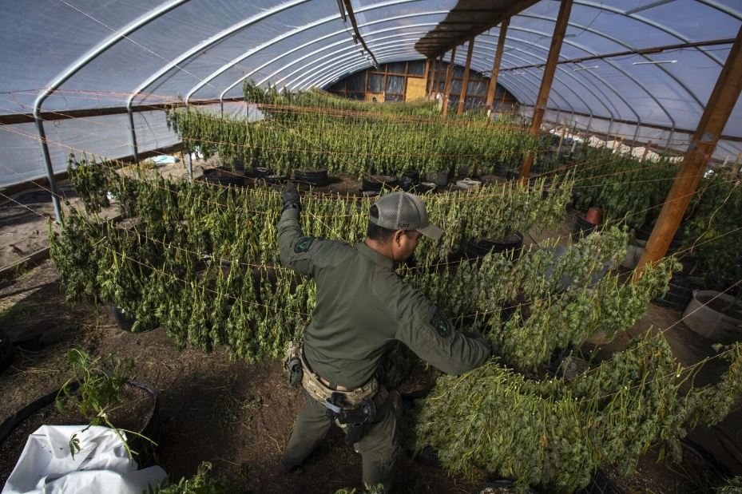
Cannabis tops hang to dry in a greenhouse raided by Siskiyou County sheriff’s deputies. (Brian van der Brug/Los Angeles Times)
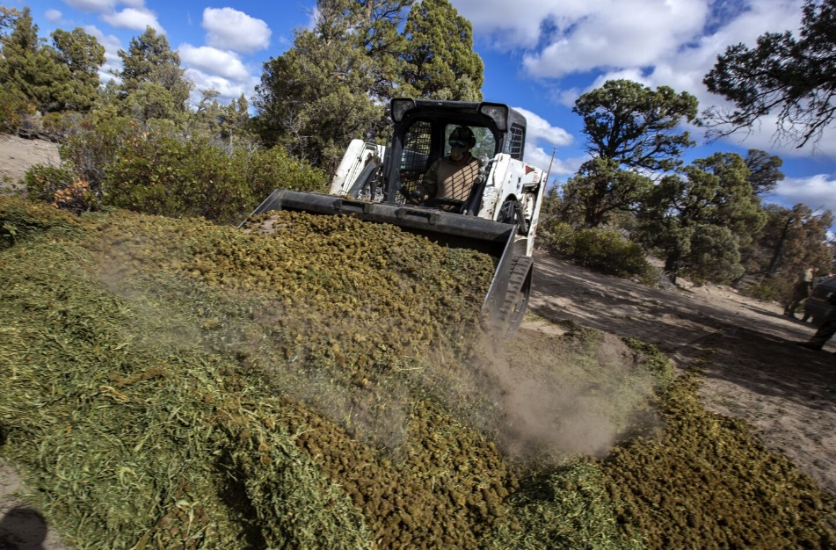
Where plants were once laboriously cut by hand, sheriff’s deputies use heavy equipment to clear illegal greenhouses and bury hundreds of pounds of illicit cannabis. (Brian van der Brug / Los Angeles Times)
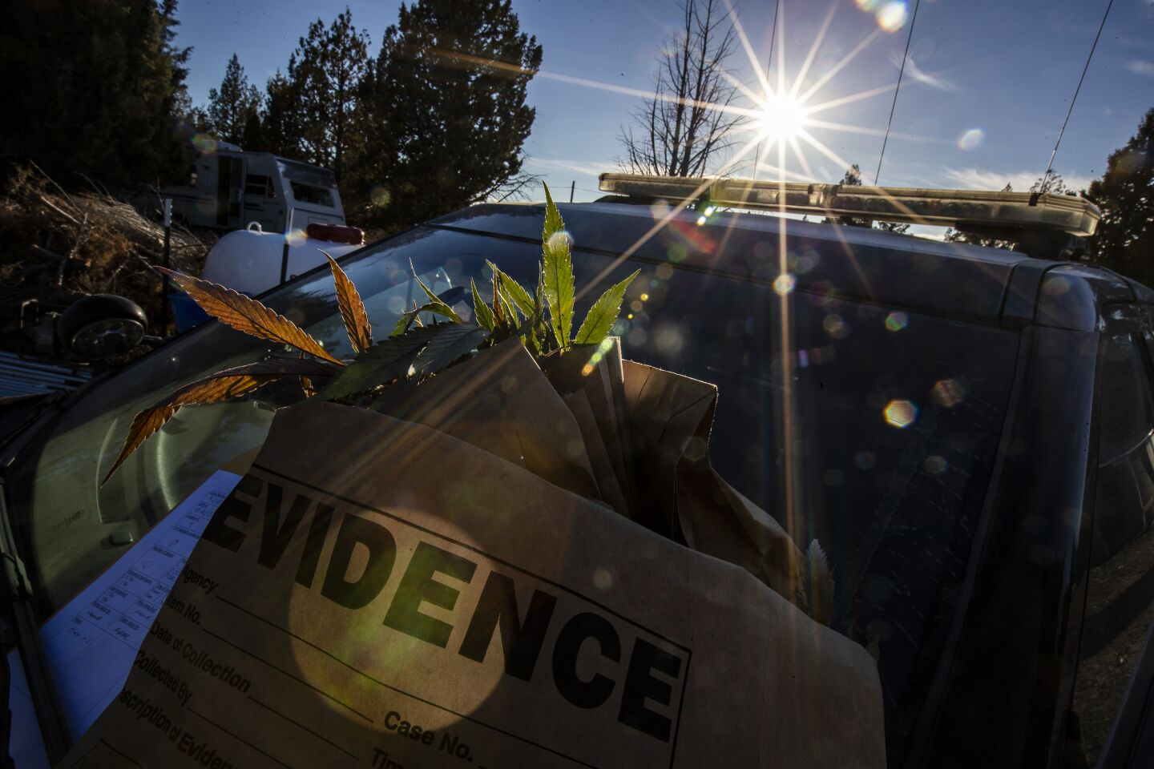
Though criminal charges are rare, a small sample of illicit cannabis is saved for evidence during police raids in Siskiyou County. (Brian van der Brug/Los Angeles Times)
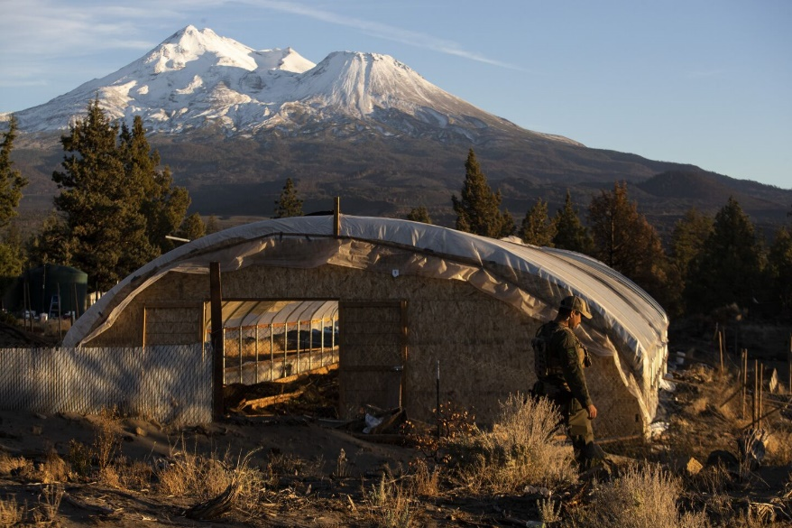
Mt. Shasta towers in the distance over an empty hoop house. The plants within had already been harvested by the time it was raided by Siskiyou County sheriff’s deputies. (Brian van der Brug / Los Angeles Times)
Some cannabis camps empty their pit toilets onto the ground and trash into other holes. When the wind blows, empty fertilizer bags wrap themselves around fences like tumbleweeds. Growers have bulldozed parcels flat, scraping away vegetation, and the land is cut by deep erosion scars littered with empty water totes and growing piles of detritus. With the market collapse, some of the hoop houses are abandoned, and dogs that once guarded the farms now run in packs that sometimes attack cattle, and are frequently found dead or starving.
“All of that’s illegal. Nobody seems to care,” said Persing, exasperation wearing on his voice.
Beyond Highway Patrol and wildlife officers who sometimes lend a hand with physical labor, Persing said, “we don’t get much help from any state agency.”
Struggling licensed cannabis growers like Mary Gaterud also feel abandoned.
She is part of the cultural movement that was at the core of California’s early cannabis industry.
Gaterud earned a master’s degree in existential phenomenal psychology, took a look at her job prospects in the late 1990s, and thought, “Yeah, I think I’m just going to drop out and grow weed.” She set up a small outdoor cannabis farm in Humboldt County on the banks of the Eel River.
Her plants are organically nurtured in microbe-rich soil and mulched with a winter cover of fava beans. She spent years developing sweet-scented stocks, grown herself from seed, so that when she pops opens a harvest tub in her state-inspected processing facility, a converted root cellar, the smell is heavy with pineapple and coconut.
Her harvest fell victim to a glut in cannabis that drove down wholesale prices. A pound of dried flower, which just a few years earlier would sell in California for more than $2,000, was now worth less than $300. If it sold at all.
Late last year, as Gaterud cut the summer’s harvest, her distributor in Los Angeles shipped back her 2020 crop, unsold and so damaged by poor storage Gaterud wasn’t even sure it was hers.
There was nothing else to do with the premium plants but ship them to an extractor to be mulched and reduced to generic oil.
Gaterud and many other small farmers now face financial disaster.
“I’m barely hanging on,” she said.
The glut was driven by two factors: the surge in illegal growing and the state’s issuance of licenses to grow more cannabis than Californians consume.
Nicole Elliott, the governor’s cannabis advisor and the head of the Department of Cannabis Control, said she believed California’s licensed cannabis crop was about 3.6 million pounds, in a state that consumed less than 2 million pounds.
Nicole Elliott, right, Gov. Gavin Newsom’s cannabis advisor and the director of the Department of Cannabis Control, speaks at a cannabis growers’ gathering in 2021. (Andy Colwell)
The Times’ analysis of state licensing records and production estimates put the state’s 2021 legal crop at well more than 7 million pounds, even accounting for crop failures and growers who did not plant.
Asked about The Times’ findings of increased illegal cultivation, Elliott said: “Do I think it’s worse? I honestly couldn’t say one way or another.”
Elliott said ensuring the integrity of the legal market is her first focus “before we expand those efforts out to the illegal market.” Other state agencies, she said, are better equipped to contend with illicit grows.
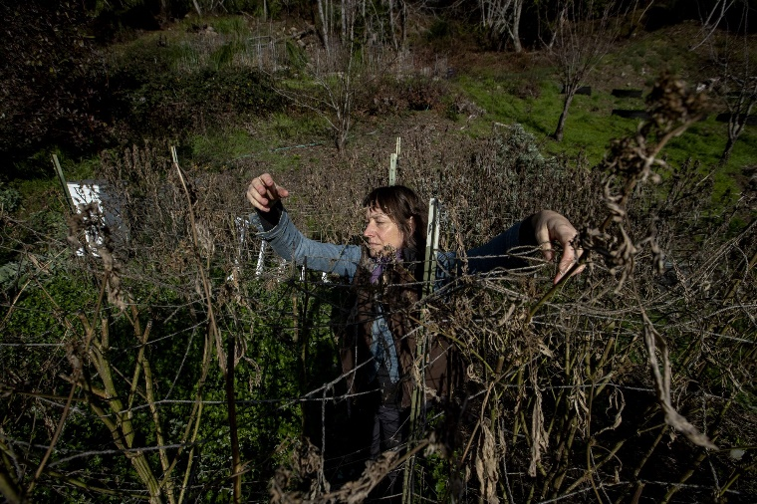
Mary Gaterud, a licensed small-scale grower, clears remnants of her 2021 crop in rural Humboldt County. (Brian van der Brug / Los Angeles Times)
Still, she said, “it’s not like we’re sitting on our hands doing nothing.”
In July, the department issued a news release heralding the removal of illicit cannabis from the market, but detailed warrant logs obtained by The Times under California’s public records law show most of those seizures were led by other police agencies. In the year since July 2021, the department’s 59 sworn officers have initiated only 26 of their own warrants against illicit growers.
The department’s enforcement chief told The Times he was unable to provide a list of criminal cases that resulted from those efforts.
The logs show most of the division’s focus is on urban areas and Southern California. In that same time frame, the Department of Cannabis Control enforcement actions in Mendocino County — beset with violent, large-scale criminal operations — were limited to a single day of raids on four small farms along a creek, at the behest of wildlife officers. There were no arrests.
The remainder of state enforcement is fractured and limited in focus. National Guard teams still conduct summer raids that slash plants, but they remove less than a quarter of the crop of eradication campaigns a decade earlier. The state water resources boards were front-runners in approaching illicit cannabis as an environmental threat, but when fees from cannabis permits fell short of budgeted projections, the boards in 2020 cut their cannabis enforcement departments by half.
The biggest state player in combating illicit cannabis is the Department of Fish and Wildlife, which focuses on the impact growers have on streams and fauna.
Cannabis growing that endangers either remains a felony. But the 68 Fish and Wildlife cannabis field officers who have the expertise to document those crimes are spread thin. Nine agents cover the seven-county area responsible for an estimated 40% of illegal cultivation.
State regulators have had authority since 2019 to fine unlicensed growers up to $30,000 a day, and to seek civil penalties that can exceed $300,000 a day.
Although the state has sanctioned licensed growers for violating regulations, The Times found the state attorney general has never invoked civil penalties for unlicensed cultivation. The Department of Cannabis Control used the tool once — against a Shasta County school janitor and his wife accused of leasing their land for nine illegal greenhouses.
Elliott could not explain why the case was filed at all. She said it was a departure from what she believed department priorities should be.
Other states experiencing rampant outlaw activity have taken more aggressive measures. In Oregon, the problem prompted a special session of the Legislature to step up police raids and services for exploited workers. Oklahoma’s attorney general is investigating law firms accused of helping growers skirt residency requirements.
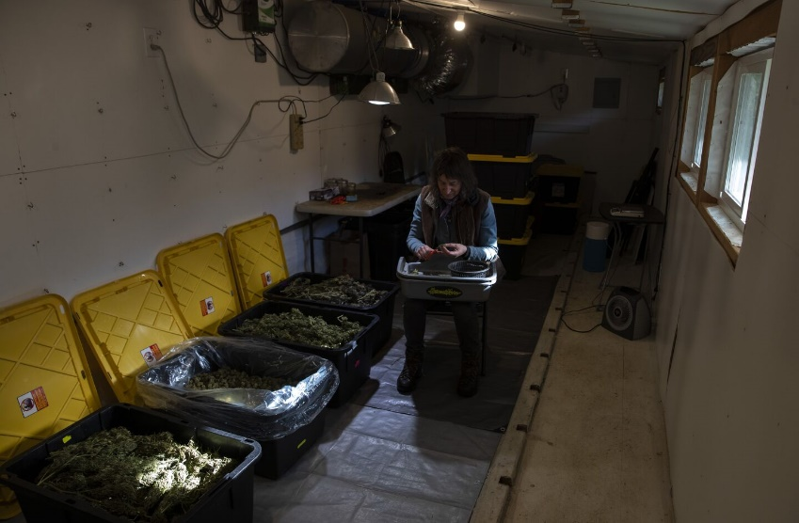
Small-scale cannabis farmer Mary Gaterud, trying to survive in the legal market, trims her cannabis harvest remaining from the prior season. (Brian van der Brug/Los Angeles Times)
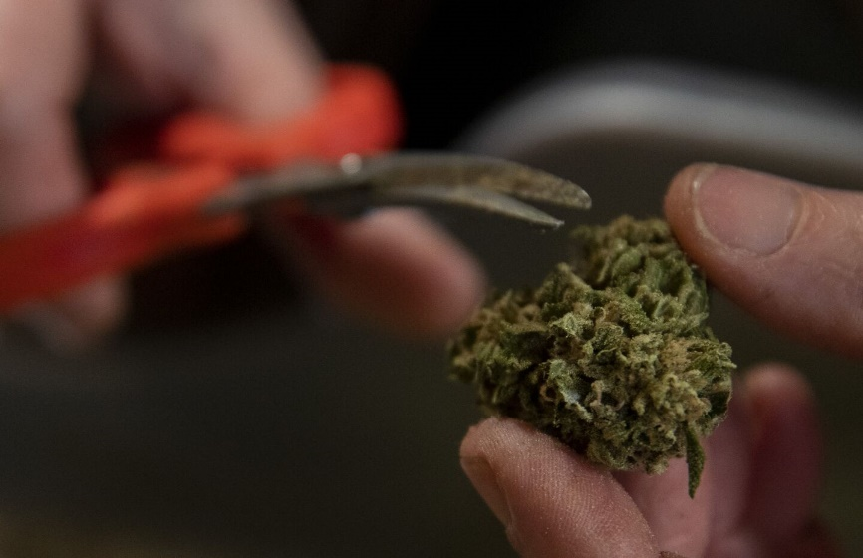
Licensed cannabis farmer Mary Gaterud nurtures such strains as pina colada cake and watermelon starburst. (Brian van der Brug/Los Angeles Times)
Strong scents of pina colada waft from cannabis in storage, as licensed grower Mary Gaterud waits to find a legal market for her crop. (Brian van der Brug/Los Angeles Times)
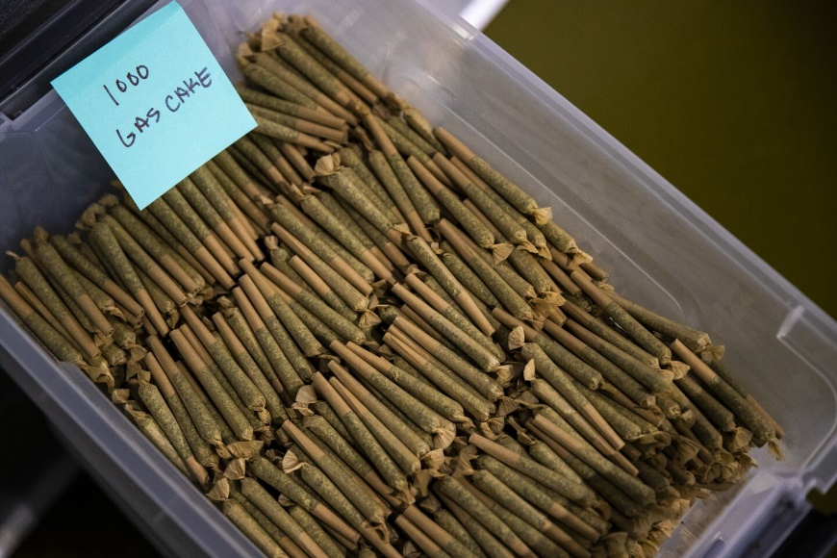
Licensed cannabis extractor Eric Martin in Humboldt County keeps pre-rolls in temperature- and humidity-controlled storage, awaiting a market. (Brian van der Brug/Los Angeles Times)
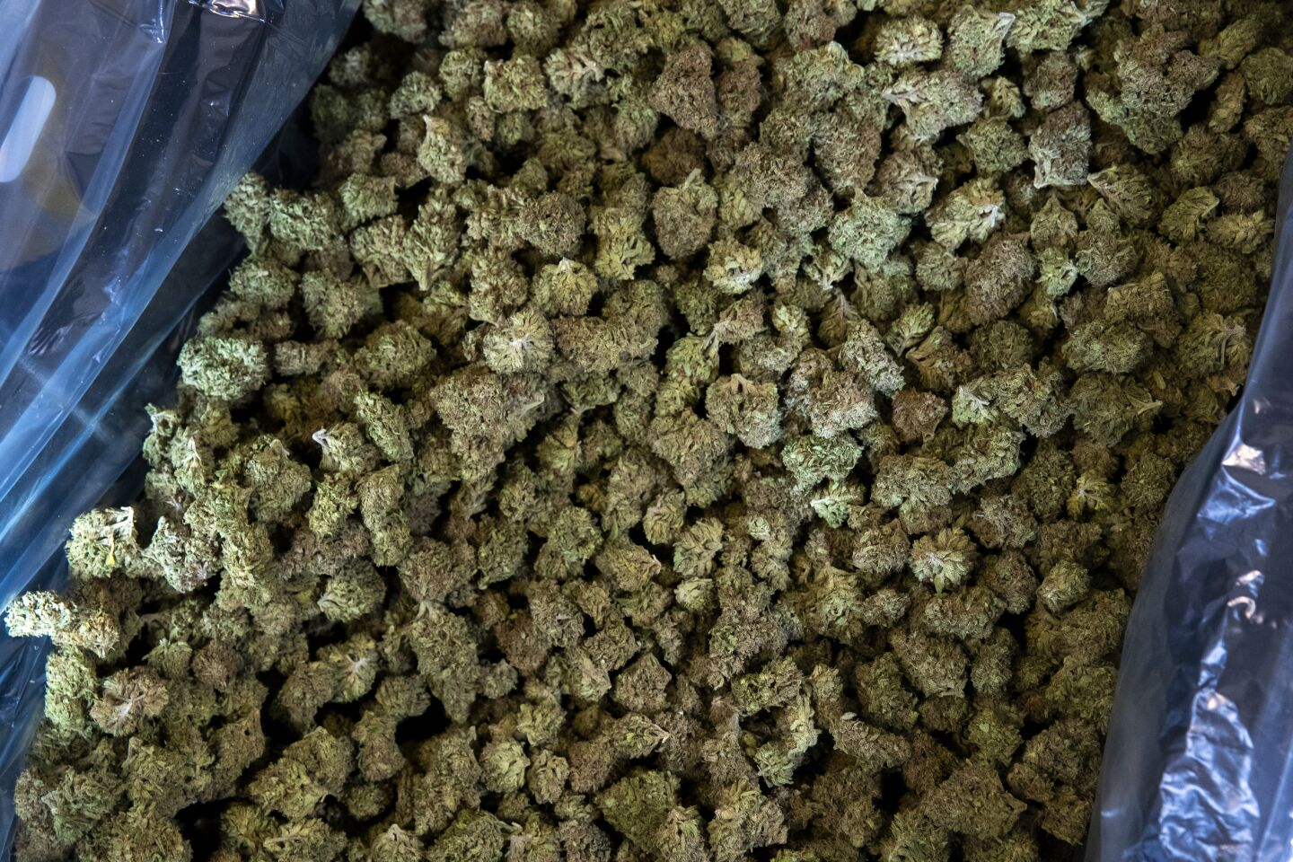
Trimmed buds in storage, unsold, at Mary Gaterud’s licensed farm. (Brian van der Brug/Los Angeles Times)
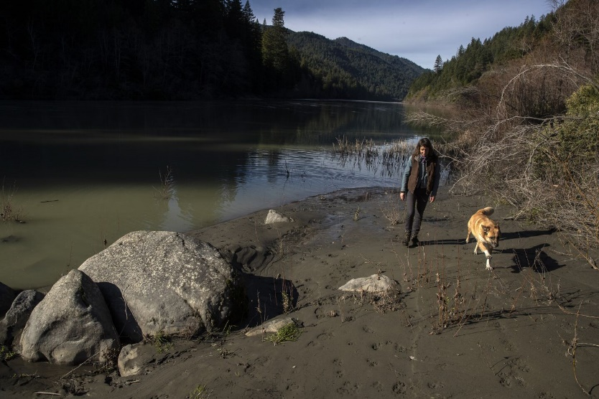
Mary Gaterud walks the bank of the Eel River with her dog, Blix. Despite a market glut from both legal and illegal grows, the remote area, reachable only by boat during high water, has begun to attract large cannabis operations. (Brian van der Brug/Los Angeles Times)
Gaterud, on her farm deep in the mountains of Humboldt County, said she feels betrayed by California and angry that she suffers while those flouting the law go unstopped.
Regulators, she said, repeatedly demanded detailed drawings of her farm’s plans and conducted nine separate inspections. She estimates she spent $100,000 on fees and improvements to her property to meet local and state requirements.
As the winter rains set in, she began borrowing money from friends and relatives to live on. She got a part-time online job as coordinator of an astrology school to make ends meet.
Her 2021 crop came back from the distributor, also unsold.
“I’m afraid that I am one bad piece of news away from having to list my property,” she said, “and abandon my dream, life, everything I have fought for.”
In the summer of 2020, Julian “Terps” Sanchez left his Orange County apartment for long buying trips in Northern California to scour illegal farms for 100-pound boxes of processed cannabis buds.
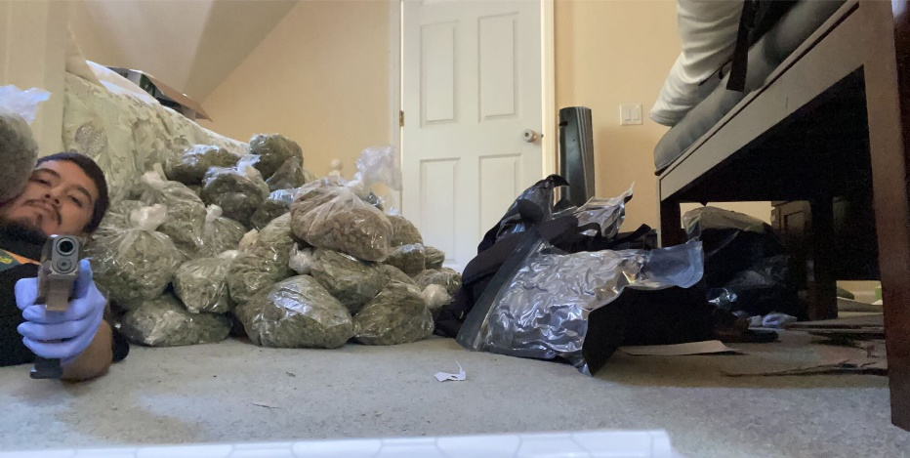
Costa Mesa resident Julian “Terps” Sanchez, shown here on a Snapchat image filed in federal court, admitted supplying a Milwaukee drug ring with hundreds of pounds of illicit California cannabis. (Wisconsin Department of Justice)
At home, his father, a former meth distributor named Miguel Sarabia, used a strip mall cellphone and satellite dish franchise in Lakewood to build a clandestine lab to make distilled oil for edibles and vaping cartridges imported from Hong Kong.
The father and son represented the connection that enables illicit growers like those in Mount Shasta Vista to reach a national market.
Sanchez supplied a Milwaukee operation some 250 pounds of cannabis a month, and his father provided thousands of vape cartridges, according to plea statements and other court filings. In just six months, the California wholesalers were paid an estimated $1.7 million, much of it sent through the mail with bills painstakingly taped between the pages of magazines. It was a low-risk drug that commanded high street prices, especially sold as vape cartridges, Sarabia’s defense lawyer said, making cannabis more attractive and more lucrative than cocaine or heroin.
On the Milwaukee side, affidavits and plea statements filed in federal court detail stash houses, business fronts and large weapons caches that included untraceable “ghost guns.” The arsenal of one woman, who gathered family members in a basement to assemble vape cartridges, included a baby blue Glock on her dresser and another Glock in a baby bassinet. The ring’s local leader was a Mexican Posse gang member who, an informant told investigators, twice boasted of shooting a “snitch.”
Sarabia had his eyes on the expanding world of legal cannabis. Should Wisconsin approve recreational cannabis, he claimed on a 2020 wiretapped call, influential political connections guaranteed Sarabia a wholesale license. He had already bought the building.
“I’ll be the first one,” he boasted.
Federal and state investigators in Wisconsin shut down the trade in late 2020, charging 26 defendants. Sanchez pleaded guilty to drug and gun charges for a 10-year sentence. Sarabia admitted to a single drug conspiracy charge and was given five years in prison. None of the farms supplying the drug ring were identified.
Few ever are.
Police and prosecutors told The Times that cannabis-related crimes are a low priority, even in the federal court system, where cannabis is classified the same as heroin and LSD. They described unwritten hurdles their investigations must clear — such as proof of laundering millions of dollars — before superiors will approve money and time to prosecute. In the rare instances when charges are filed, they generally don’t target the people who head or fund the operations.
Federal justice officials in 2018 heralded investigators who used utility bills and tracking devices to identify some 130 indoor grow houses in Sacramento run by a network of buyers who wired money from China. Nearly half of the 21 people charged were Chinese citizens.
Five years after the first arrests, most of those charged have yet to go to trial. The operation’s leaders weren’t identified. A federal official connected with the case, who was not authorized to speak publicly, said Chinese authorities won’t cooperate on such investigations and U.S. Justice Department supervisors in Washington, D.C., did not give the green light to continue digging.
The best hope, he said, was to seize local assets and “disrupt the finances ... and put pressure on whoever is organizing this stuff.”
Nearly half of the money for the grow houses came from local private investors who made high-interest loans to buyers with few obvious financial resources. Court records show the lenders included a Sacramento physician who told the court he hated cannabis, but was unwittingly steered into underwriting illegal grow houses by a real estate agent now charged in the conspiracy. And, he said, it was very profitable.
Federal prosecutors allowed him, as they do with other such lenders, to recoup his money when the property sold, even though a forfeiture motion remained pending.
In one of the few federal cases that resulted in a conviction for illegal cultivation, probation officials recommended four years in prison for Aaron Li.
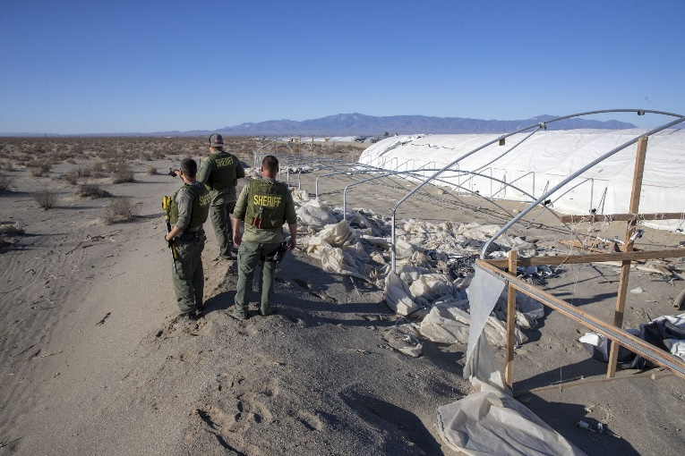
San Bernardino County sheriff’s deputies scan the desert for workers who ran off during a police raid of an unlicensed cannabis farm. (Brian van der Brug / Los Angeles Times)
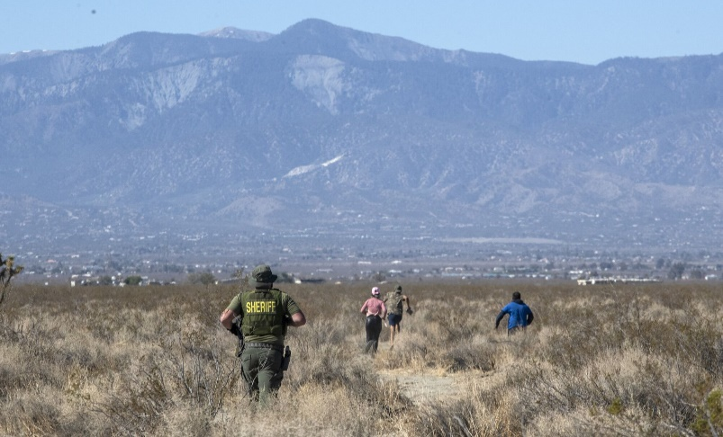
A San Bernardino County sheriff’s deputy chases fleeing workers during the raid of an illegal cannabis operation. (Brian van der Brug / Los Angeles Times)
Li, who has a PhD in vision science from UC Berkeley, used money from unindicted conspirators in China to turn nine suburban homes in San Bernardino County into clandestine grow houses. Court records laid out the mechanics of a sophisticated scheme that ran until 2019, involving stolen electricity, straw buyers, fake leases, purloined passport information and money moved from China to shell companies in the U.S. One of the participants was a confessed money-laundering courier for a Mexican narcotics ring.
Li’s defense lawyer told a judge that his client was acting under orders from unnamed bosses he feared, a claim she repeated to The Times.
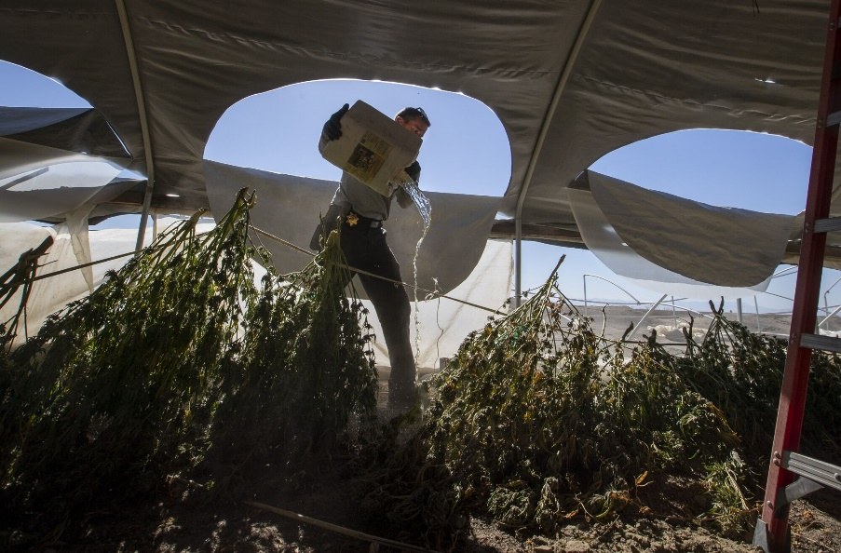
A San Bernardino County sheriff’s deputy dumps fertilizer to foul cannabis plants during a raid on an illegal operation. (Brian van der Brug / Los Angeles Times)
U.S. District Judge George Wu initially announced an eight-month sentence. After Li said that he had young children, the judge reduced it to six months.
“Marijuana is being cultivated legally — it’s just a question of getting the licenses,” Wu said during sentencing. “There’s so much of it. So why would I impose a lengthy sentence?”
A federal prosecutor in the case said there was no interest in investigating beyond Li, saying the case had met its primary goal, shutting down a community nuisance.
State Assemblyman Thurston “Smitty” Smith (R-Apple Valley) this winter proposed restoring felony charges for large-scale growers, but with no co-signers he yanked the doomed bill before its first hearing. His substitute measure to increase civil fines passed the Assembly but failed to progress in the Senate.
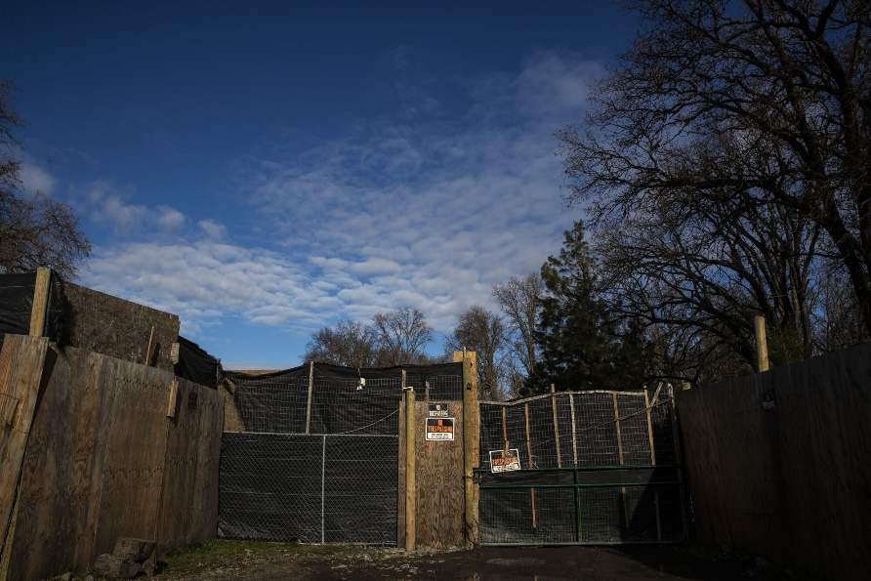
High fences and signs warn visitors to keep out of a cannabis grow in Covelo. (Brian van der Brug / Los Angeles Times)
A growers’ group, the California Cannabis Equity Alliance, called the proposed increase in fines “a symbolic deterrent that will be good for a press release and little else.”
“The potential profits to be made are too great.”
In the bowl of a beautiful and tragic valley bordered by the Eel River in Mendocino County sits tiny Covelo.
It was the site of California’s largest state-financed massacre — a campaign that in 1856-59 slaughtered more than 1,000 Yuki tribal members — and the destination for the U.S. military’s forced march of five more tribes. Remote and at times unreachable, the community has struggled since the downturn of the timber industry and closure of the local flour mill.
Cannabis plants on an illegal grow blow in the wind. (Brian van de Brug/Los Angeles Times)
But Covelo had cannabis.
Small outdoor cash crops were common on Round Valley’s patchwork of private, federal and reservation lands. Mendocino County and the tribes were tolerant, even if the U.S. Bureau of Indian Affairs did not approve.
After legalization, outsiders rolled into the town in expensive, lifted trucks with Central Valley license plates, moving as a group. They began leasing land from tribal members.
By the summer of 2021, the town was overtaken. A Times analysis of satellite images showed the valley floor that summer had 1,033 homes and 2,423 cannabis hoop houses, almost one for every resident.
More than half are unlicensed. Hoop houses not only fill farm lots, but backyards and front yards. They stand by the schools, behind the auto parts store, beside the Catholic chapel.
“We have been totally overrun,” Round Valley Indian Tribes director James Russ said at a county advisory committee meeting last year. “Not just this reservation, but also this whole valley.”
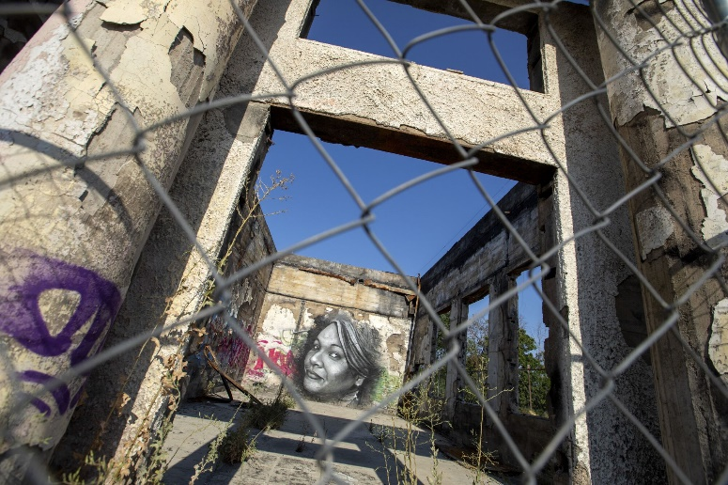
A mural inside a gutted building in Covelo’s business district. Residents say illegal cannabis growers seek to take advantage of the community’s economic plight. (Brian van der Brug / Los Angeles Times)
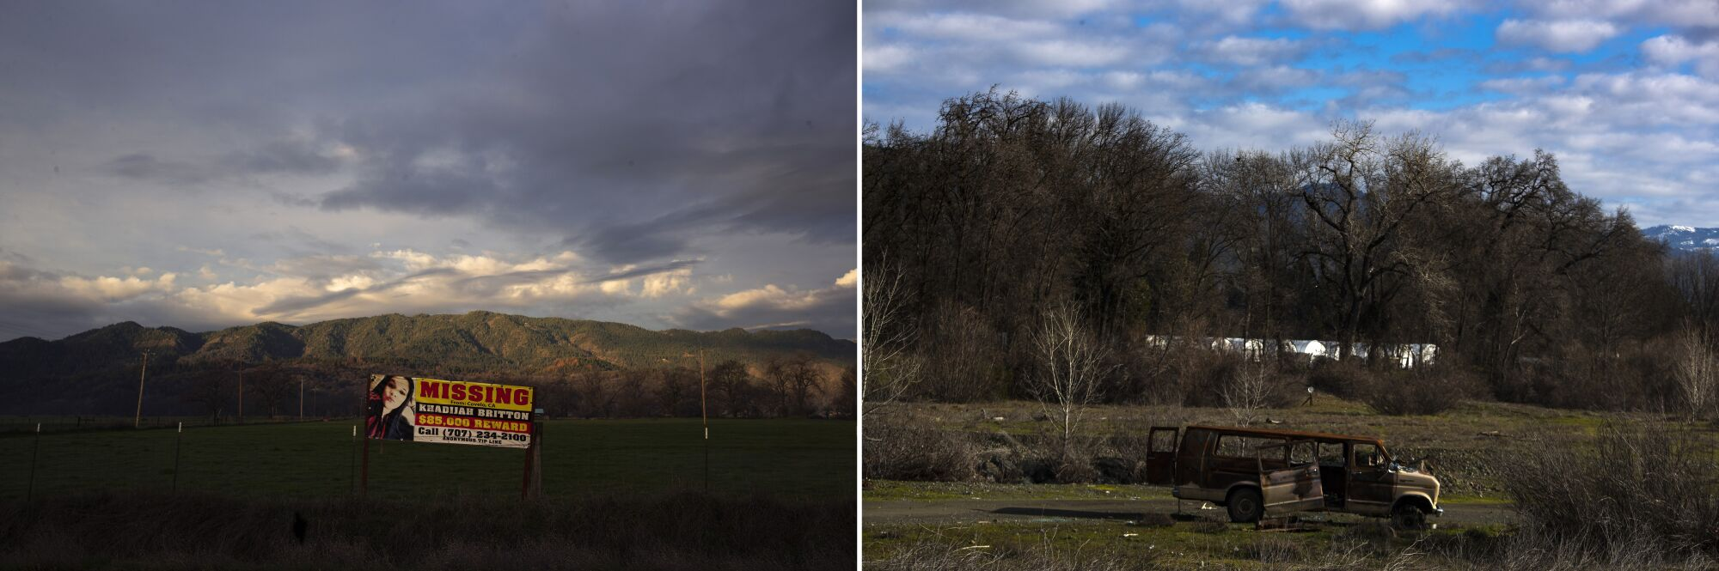
Left: Clouds drift over Round Valley and a sign asking for help finding Khadijah Britton, a member of the Round Valley Indian Tribes who has been missing since 2018, when she was 23. Right: Abandoned vehicles and cannabis hoop houses are common sights in Covelo. (Brian van der Brug / Los Angeles Times)
With the surge in illegal cultivation came heavy-duty weapons, violence and lethal chemicals. On one 2021 raid, deputies found bottles of Metrifos, with “peligroso” — dangerous — and a skull and crossbones on the label. The nerve poison, taken off the U.S. market in 2009, is still sold in Mexico to protect crops from rodents. The sheriff said one deputy became ill after the raid and was hospitalized with poisoning symptoms.
Working conditions on the farms are harsh. Laborers described 14-hour days, living in tents without sanitation and having to provide their own food with the promise of pay after the harvest, if it came at all. Wage theft is so common laborers circulate lists of “no pay” farms.
In 2019, 40-year-old Jose Ramon Mejia Rios, a local man, died inside the cannabis greenhouse he was tending. The county coroner determined carbon monoxide killed him. A young woman living on the property told The Times that Rios was part of a crew of growers who leased space for their illegal greenhouses from her aunt. They pulled out after the death, she said, and others took over.
The next year, two more workers died less than a mile apart, under similar conditions, coroner records show.
Osnin Noe Quintanilla-Melendez, 32, from Honduras died sleeping in a cannabis hoop house with a running generator.
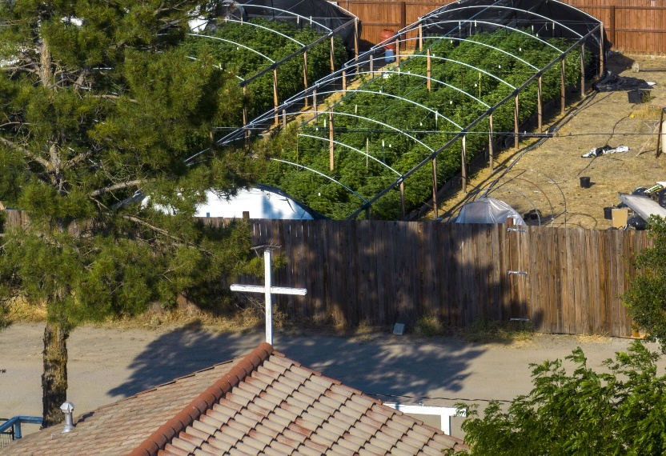
Cannabis hoop houses fill the backyard of a home adjacent to the Our Lady Queen of Peace Roman Catholic Chapel in Covelo. (Brian van der Brug / Los Angeles Times)
Across from the local landfill, on a site with 52 illegal greenhouses, Wilson Andres Rodriguez Villalobos, a 32-year-old worker from Colombia, was found face-down inside an illegal greenhouse warmed by propane torches.
Months later, on the same farm, another worker disappeared. Victor Medina’s family in San Jose received a ransom call from kidnappers unable to prove the missing man was still alive.
“Cuidado con Covelo,” one person wrote on a WhatsApp forum for cannabis workers, “que esta muy turbio.”
Watch out for Covelo. It’s very shady.
“Aparecen muertos a cada rato.”
Dead people appear all the time.
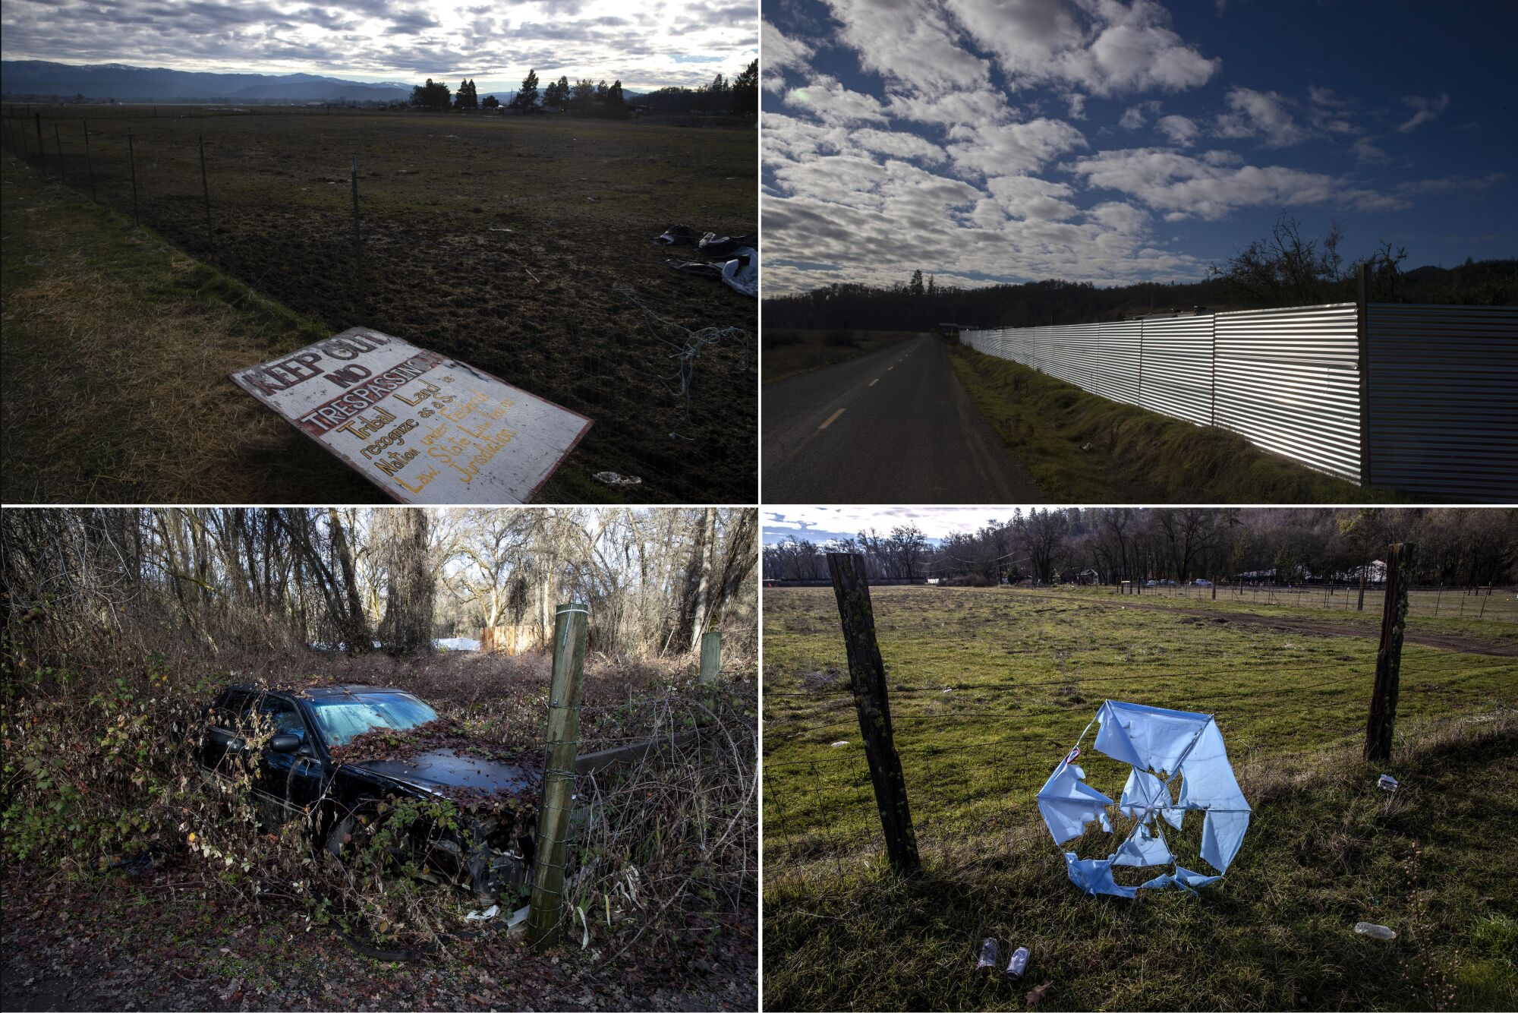
Clockwise from top left: A sign warns visitors to keep off tribal land; a fence hides a cannabis operation; a tattered umbrella leans among roadside litter; and blackberry brambles cover a car parked outside a Covelo cannabis operation. (Brian van der Brug / Los Angeles Times)
In the late fall, a game warden investigating the smell from an abandoned car outside Covelo opened the trunk to find the decomposed corpse of Marco Antonio Barrera Beltran, 51, a Mexican citizen who’d been living in the Central Valley. The sheriff said he had been working on an illegal cannabis farm in Covelo. Beltran had been shot to death.
The murder investigation included a search of a bank of cannabis farms where another worker died of carbon monoxide poisoning the year before. But the case remains unsolved.
Covelo residents who spoke to The Times asked that their names not be used because they were fearful of the growers around them.
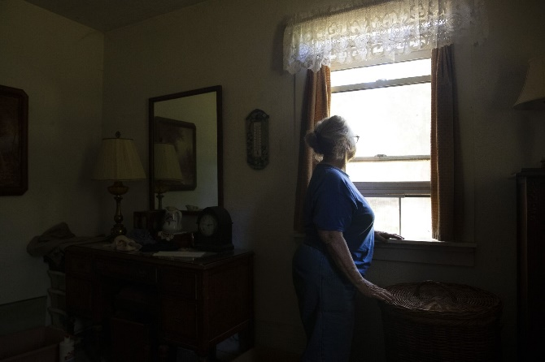
A Mendocino County resident looks out her bedroom window. At night she must block the glare from brightly lit cannabis greenhouses surrounding her house with cardboard. (Brian van der Brug / Los Angeles Times)
One woman’s water well now runs dry each May, the shallow aquifer tapped by massive greenhouses that surround her house on three sides. She has gone to extremes: let the garden die, collect drips from the faucets, clean dishes with a spray bottle, and rely on a garden hose from the neighbors and a storage tank to get through the summer. The growers next door haul in water by the truckload. Their generators run constantly, workers defecate in her yard, and she must block her windows at night with cardboard to cut the glare from greenhouses.
Other residents described finding a cannabis worker, unpaid and stranded in the hills, weeping and afraid his employer would return to kill him. During a recent raid of an illegal farm, sheriff’s deputies encountered two workers from Mexico who said they had been held there against their will.
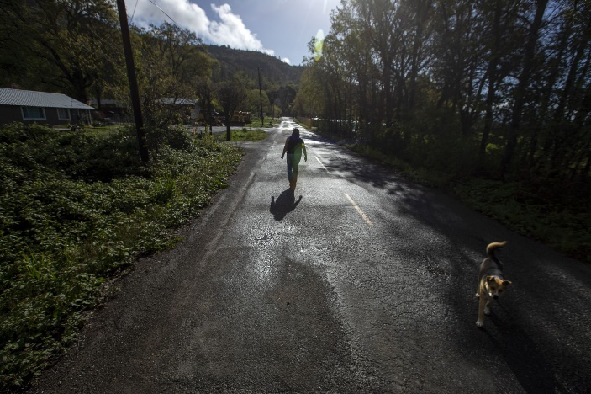
Accompanied by a stray dog, Kat Willits, a former council member of the Round Valley Indian Tribes, walks down a Covelo lane reminiscent of the community’s rural past. (Brian van der Brug / Los Angeles Times)
“Right now, from the decimation I see in my valley, it ... breaks my heart,” said Kat Willits, a local school administrator and former council member of the Round Valley Indian Tribes.
Willits spent her childhood in Covelo visiting family, roaming the valley, swimming in the creek beside spawning salmon. She was appalled to return as an adult and find so many community members dependent on leasing to illegal growers.
“Some people say that’s the only way they can make money now,” said Willits. "[But] they’re not making money... they’re also decimating their own land with the byproducts of cannabis grows.”
She said cannabis cash has hastened Covelo’s social decay, not uplifted it. There are more junked cars, more decaying homes, and more violence.
“Great tradeoff,” she said, with apparent sarcasm, “for some California college kids to be able to puff on a pen filled with a cannabis product in public.
“What people think of as a harmless drug or medicinal product have not seen what lies in the belly of the beast.”
Accessed: https://www.latimes.com/california/story/2022-09-08/reality-of-legal-weed-in-california-illegal-grows-deaths

